|  |  |
| --- | --- |
| **Name of Student :** | **Adm No. U20CSzzz** |
| For an Example : **AM MODULATION & DEMODULATION** | Exp. No. 01 |
| Date : DD/MM/YY |
| Pages : 01 to XX |

**EXPERIMENT AIM** : For an Example : To construct Amplitude Modulator and Demodulator circuit and plot the waveforms.

**APPARATUS & COMPONENTS REQUIRED** : (For an example as under)

|  |  |  |  |
| --- | --- | --- | --- |
| **Sr. No.** | **Name of Equipment/Component** | **Number & Range** | **Quantity** |
| 1 | Function Generator | 10 MHz | 1 |
| 2 | CRO | 20 MHz | 2 |
| 3 | Storage Oscilloscope | 100 MHz | 1 |
| 4 | Spectrum Analyser |  |  |
| 5 | Transistor | BC 107 | 5 |
| 6 | Diode | IN4001 | 2 |
| 7 | Resistors | Different values | 12 |

**BRIEF THEORY OF TOPIC** :

**BLOCK DIAGRAM (IF APPLICABLE) :**

**CIRCUIT DIAGRAM (IF APPLICABLE)** :

**PRACTICAL PROCEDURE :**

1. Connect the circuit as shown in figure…………….
2. ………………………………………..
3. ………………………………………………

**OBSERVATION TABLE IN TABLE FORM FOR INPUT & OUTPUT :**

For an Example as hereunder.

**INPUT SIGNAL**

|  |  |  |  |
| --- | --- | --- | --- |
| **Signals** | **Amplitude (V)** | **Time period (ms)** | **Frequency (KHz)** |
| Modulating signal |  |  |  |
| Carrier signal |  |  |  |

**MODULATED SIGNAL:**

|  |  |  |  |
| --- | --- | --- | --- |
| **Emax (V)** | **Emin (V)** | **m = (Emax – Emin)/ (Emax + Emin) %** | **Type of modulation** |
|  |  |  |  |
|  |  |  |  |
|  |  |  |  |

**DETECTED SIGNAL:**

|  |  |  |
| --- | --- | --- |
| **Amplitude (V)** | **Time period (ms)** | **Frequency (KHz)** |
|  |  |  |

**CALCULATIONS :**

**CODING (IF MATLAB / MULTISIM BASE) :**

**MODEL GRAPH / WAVEFORMS : (For an Example as hereunder)**

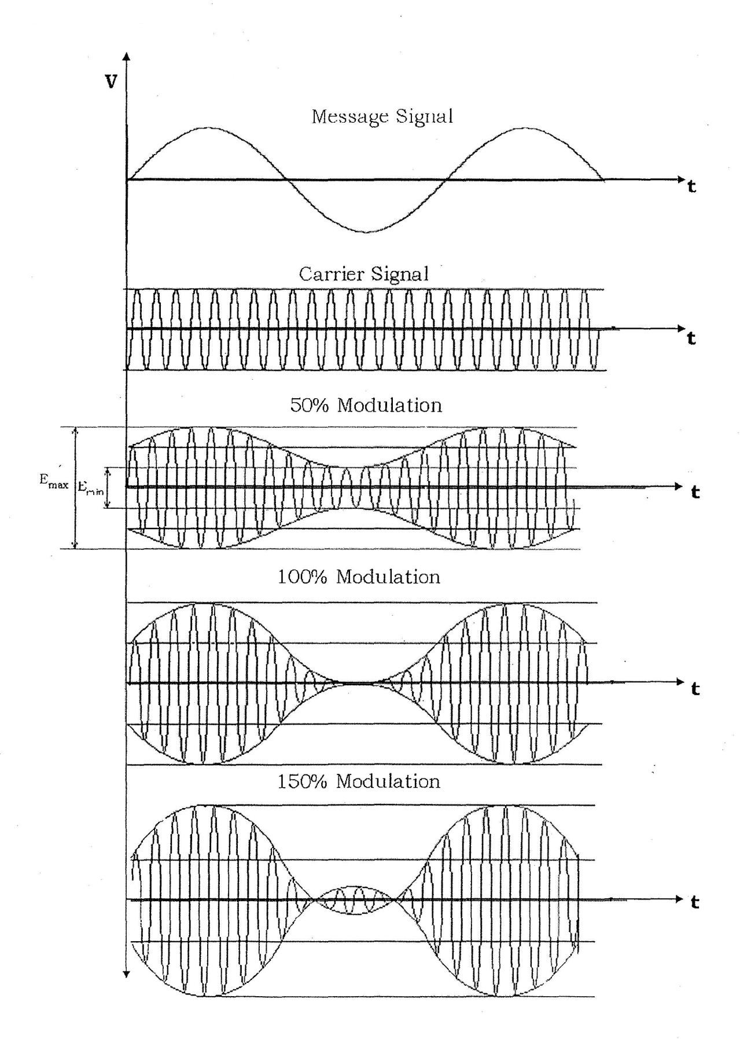

**RESULTS :**

**ADVANTAGES :**

**DISADVANTAGES :**

**APPLICATIONS :**

**CONCLUSION :**